A000-Afr-DR Congo-Nkisi-Statue-Male-Wood-19th c

*Note: The Democratic Republic of the Congo has been known as, in chronological order, the Congo Free State, Belgian Congo, the Republic of Congo-Léopoldville, the Democratic Republic of the Congo and the Republic of Zaire, before returning to its current name the Democratic Republic of the Congo or DR Congo.*

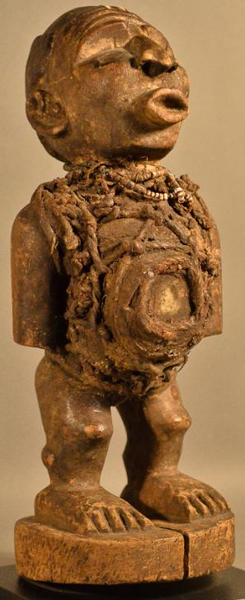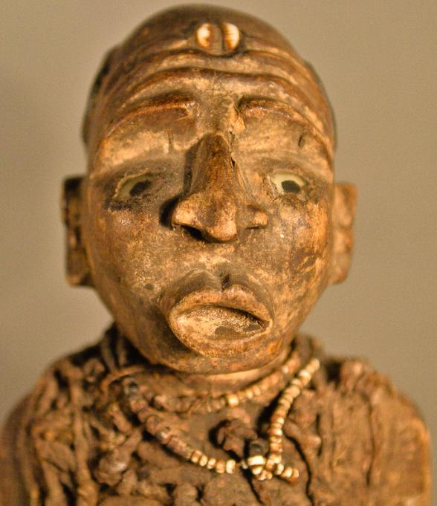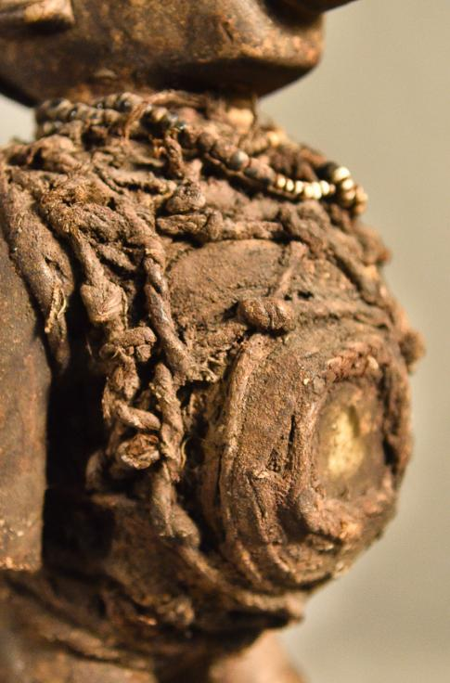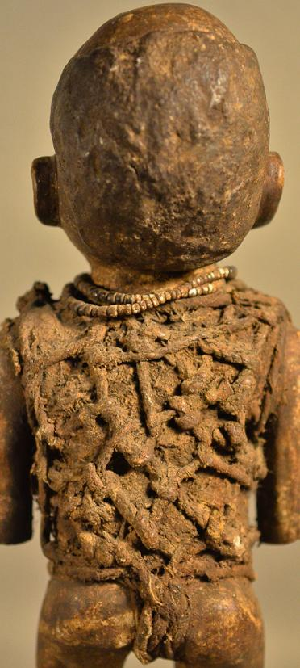

Figs. 1-4, Afr-DR Congo-Nkisi-Statue-Male-Wood-19th c

**Case no.:**

**Accession Number:**

**Formal Label:**

**Display Description:**

The Nkisi is a wooden sculpture in which inheres a spiritual being with the physical attributes of a woman shaman who is powerless until she has been activated by the need of a patient. This Nkisi has a classic Kongo face with expectant glass eyes and wrinkled brow (suggestive of the serious effort being exerted. Its forehead is adorned with a cowry shell which is shaped like the womb and therefore symbolic of successful childbirth (MacGaffey 1988:192). The cowry is "kodya" in the Kongo language, which evokes the word "kola", "to be strong." The exhortation of this powerful midwife to the mother-to-be, demonstrated by her protruding lips and everted nose indicating the need for labored breathing and bent knees suggestive of an advantageous child-bearing position. Pregnancy is also emphasized by a protruding belly that is covered with mysterious medicinal paraphernalia and divination objects -- wrappings of rope, roots and a leather pouch (which also contains other powerful but unseen, hence mysterious, objects such as efficacious insects and snake teeth). All of these unseen objects are affixed with secret types of knots securing these hidden objects with their mysterious powers to her body and by sympathetic magic to that of the patient. Her arms are at her side, showing attentiveness to the patient and are consistent with her well-carved ears suggesting that she is ready to hear entreaties. A small, beaded, white, shell necklace is encrusted with libations after years of use.

**LC Classification:**

**Date or Time Horizon:**

**Geographical Area:**

**Map:**

**GPS coordinates:**

**Cultural Affiliation:** Kongo peoples. Since archaeological evidence linked to the Kongo people has not been found, glottochronology – or the estimation of ethnolinguistic time-depths applied to the Kongoindicates that the Kongo language and Gabon-Congo language likely divided about 950 BCE. (Vansina 1990, 198-199).

**Media:** wood, raffia, shells,

**Dimensions:**

**Weight:**

**Condition:**

**Provenance:**

**Discussion:**

**References:**

MacGaffey, W. . 1988. “Complexity, astonishment and power: the visual vocabulary of Kongo minkisi,” *Journal of African Studies* (14:2): 188-203.

Vansina, Jan M. 1990. [*Paths in the Rainforests: Toward a History of Political Tradition in Equatorial Africa*](https://books.google.com/books?id=6M8Wv0Tp8VwC)*.* University of Wisconsin Press.